Integrate Zscaler with Identity Providers
(IdPs) such as Azure AD, Okta, and Active
Directory for seamless authentication and authorization.

Title of the project :-

Integrate Zscaler with Identity Providers (IdPs) such as Azure AD, Okta, and Active Directory for seamless authentication and authorization.

LIST OF TEAMMATES

Team Id:SWTID -2026-5730

S.no | Name | College | Contact
1 | ILLAKIYA P | Sri Krishna Adithya College of Arts and Science | 23bsit123illakiyap@skacas.ac.in
2 | HARSHINI S | Sri Krishna Adithya College of Arts and Science | 23bsit122harshinis@skacas.ac.in
3 | KARTHICK S | Sri Krishna Adithya College of Arts and Science | 23bsit128karthicks@skacas.ac.in
4 | GOKUL A | Sri Krishna Adithya College of Arts and Science | 23bsit118gokula@skacas.ac.in
5 | JOEL J | Sri Krishna Adithya College of Arts and Science | 23bsit126joelj@skacas.ac.in

Project details

Title: Integrate Zscaler with Identity Providers (IdPs) such as Azure AD, Okta, and Active Directory for seamless authentication and authorization.

This project outlines the strategy and implementation plan for integrating the Zscaler security platform with our organization's core Identity Providers (IdPs): Microsoft Entra ID (Azure AD), Okta, and on-premises Active Directory (AD). The primary objective is to create a seamless, secure, and automated framework for user authentication and authorization across all Zscaler services.

By moving away from disparate local user management and leveraging these centralized identity sources, we aim to establish a true Zero Trust architecture where access is continuously verified based on user identity and context. This initiative will consolidate authentication into a single source of truth, enforce consistent security policies like Multi-Factor Authentication (MFA), and streamline the user experience through Single Sign-On (SSO).

Ultimately, this integration will serve as the critical link between our identity infrastructure and our security enforcement point, ensuring that the right users have the right level of secure access to the internet and applications, regardless of their location.
Abstract:
This project details the integration of the Zscaler Internet security platform with leading Identity Providers (IdPs), including Microsoft Entra ID (Azure AD), Okta, and on-premises Active Directory (AD). The primary objective is to establish a unified identity framework that enables seamless Single Sign-On (SSO) and centralized authorization for all Zscaler services. By consolidating authentication into trusted corporate directories, this initiative eliminates the need for disparate credentials and provides a foundational element for a modern Zero Trust security architecture.
By leveraging industry-standard protocols such as SAML, OIDC, and SCIM, this integration ensures that user authentication is delegated to trusted corporate directories while enforcing consistent security policies, including Multi-Factor Authentication (MFA). This approach not only enhances the user experience by reducing password fatigue but also strengthens the organization's security posture by ensuring that every access request is verified by the identity provider before reaching Zscaler's security enforcement points.
Furthermore, the implementation of automated user provisioning via SCIM streamlines lifecycle management, reducing administrative overhead and enhancing security posture. The outcome is a robust, identity-centric security model that aligns with Zero Trust principles, ensuring that only authenticated and authorized users gain secure access to internet and cloud applications from any location. This integration effectively bridges the gap between identity governance and network security, creating a dynamic and responsive access control environment.
Use Case Scenarios:
Use Case Scenario 1: Remote Faculty Access to Research Data
A research professor is working from an off-campus conference and needs secure access to sensitive research data stored on an internal server. Instead of connecting to the full campus network via VPN, ZPA grants access only to the specific research server. The professor authenticates via the university's identity provider, and access is granted based on their role.
Output:
- User identity verified: Research_Faculty_Group
- Context-aware access enforced: Access allowed only from non-campus IP ranges
- Connection restricted: Limited to specific Research File Server (R&D_Server)
- Security enforcement: Multi-Factor Authentication (MFA) required due to off-network location
- No lateral movement: User cannot access other internal systems such as HR or student records

Use Case Scenario 2: Student Access to Library Resources
A graduate student is off-campus and needs access to licensed academic journals and databases hosted internally. Instead of requiring a full VPN tunnel, ZPA provides direct access to the library application portal. The student authenticates via the identity provider, ensuring only enrolled students can access paid subscription content.
Output:
- User identity verified: Enrolled_Student_Group
- Access scope defined: Limited to Library Portal and journal databases
- Policy enforcement: Access restricted to authorized users only, preventing credential sharing
- User experience: Seamless SSO without additional VPN client complexity
- No broad network access: Student cannot navigate to administrative systems or internal servers

Use Case Scenario 3: HR Administrator Access to Payroll System
An HR administrator requires access to the payroll system to process monthly salaries. Access must be restricted to specific work hours and require step-up authentication due to the sensitivity of the data. The administrator authenticates via the identity provider, and ZPA enforces time- based and MFA policies.
Output:
- User identity verified: HR_Payroll_Group
- Time-based restriction enforced: Access permitted only during business hours (8:00 AM – 6:00 PM)
- Step-up authentication: MFA triggered upon accessing the payroll application
- Connection restricted: Limited to Payroll Application Server
- Audit trail: Full session logging maintained for compliance purposes

Use Case Scenario 4: IT Helpdesk Remote Troubleshooting
An IT support technician needs to remotely troubleshoot a server issue while working from home. ZPA provides Just-in-Time (JIT) access to the specific server requiring maintenance. The technician authenticates via the identity provider, and administrative privileges are granted only for the duration of the task.
Output:
- User identity verified: IT_Helpdesk_Group
- Just-in-Time access granted: Admin rights elevated only for the active session
- Connection restricted: Limited to the specific target server (Server-X)
- Privilege boundaries enforced: No access to other infrastructure components (databases, domain controllers)
- Session monitoring: Real-time activity logging for security review

Use Case Scenario 5: Contractor Access to Project Management Tool
An external project manager contracted for a specific initiative needs access to the university's project management tool (e.g., Jira or SharePoint). Access must expire automatically upon contract completion. The contractor authenticates via the identity provider, and ZPA provisions time-limited access based on group membership synchronized from Azure AD.
Output:
- User identity verified: External_Contractor_Group
- Time-bound access policy enforced: Account deprovisioned automatically after contract end date
- Connection restricted: Limited to Project Management Application only
- Segmentation enforced: Contractor cannot discover or access internal resources like finance systems or student databases

Stage-1

Title Of the Project: - Integrate Zscaler with Identity Providers (IdPs) such as Azure AD, Okta, and Active Directory for seamless authentication and authorization.

Overview: -

The integration of Zscaler with enterprise Identity Providers (IdPs) represents a fundamental shift in how organizations approach secure access to applications and resources. Traditional network security models relied on VPNs and perimeter-based defenses, which often granted excessive access and created lateral movement risks. By contrast, this project leverages Zscaler's Zero Trust Exchange platform to verify identity at the application layer rather than the network layer. The integration with leading IdPs such as Microsoft Entra ID, Okta, and on-premises Active Directory establishes a unified identity fabric across the organization. This ensures that users are authenticated consistently regardless of their location or device. The project eliminates the need for duplicate user directories and manual account management within Zscaler. It creates a seamless experience where users authenticate once and gain access to authorized resources. Security teams benefit from centralized control over authentication policies and user lifecycle management. The integration supports modern authentication standards including SAML, OIDC, and SCIM protocols. Ultimately, this foundation enables true Zero Trust security where identity becomes the primary control plane.
Microsoft Entra ID integration serves as a cornerstone of this identity strategy for organizations heavily invested in the Microsoft ecosystem. The integration leverages SAML 2.0 to establish federated trust between Zscaler and Azure AD for seamless Single Sign-On. Users accessing Zscaler Internet Access or Zscaler Private Access portals are redirected to Azure AD for authentication. This allows organizations to enforce Azure AD Conditional Access policies during the authentication flow. Policies can require compliant devices, specific locations, or risk-based access controls before granting access to Zscaler. The integration extends beyond authentication to include automated user provisioning via the SCIM protocol. User accounts and group memberships are synchronized in real-time from Azure AD to Zscaler. This automation eliminates manual provisioning errors and ensures immediate deprovisioning when users leave the organization. Azure AD's extensive reporting and auditing capabilities provide visibility into authentication attempts. The result is a tightly integrated security posture that leverages Microsoft's identity capabilities to protect Zscaler-enforced resources.
Okta integration provides a flexible and vendor-agnostic approach to identity management for Zscaler deployments. As a leading independent Identity Provider, Okta connects Zscaler to a wide ecosystem of applications and directories. The integration utilizes OpenID Connect (OIDC) for modern, API-friendly authentication to Zscaler services. This approach supports rich user context including profile attributes and group memberships for policy enforcement. Okta's Universal Directory serves as the authoritative source for user identities synchronized from various HR systems and directories. The Okta Integration Network (OIN) simplifies setup with pre-built connectors and configuration guides for Zscaler. Automated provisioning via SCIM ensures that user changes in Okta are reflected in Zscaler within minutes. Lifecycle management events such as user onboarding, role changes, and terminations trigger automatic updates in Zscaler. Okta's adaptive MFA policies add an additional security layer during Zscaler authentication requests. This integration delivers a seamless experience for users while providing administrators with centralized identity governance across all Zscaler services.
On-premises Active Directory integration addresses scenarios where organizations are not ready for full cloud identity migration. Many institutions maintain extensive on-premises infrastructure with complex group policies and nested organizational units. The Zscaler Authentication Bridge (ZAB) enables secure LDAP communication between Zscaler cloud services and on-premises AD. This lightweight connector sits behind the firewall and initiates outbound connections to Zscaler, eliminating the need for inbound firewall rules. User authentication requests are securely proxied through ZAB to validate credentials against the on-premises domain controllers. Group membership information is synchronized to Zscaler for use in policy definitions and access decisions. This approach preserves investments in existing Active Directory infrastructure while enabling cloud-delivered security. Organizations can maintain strict access controls based on on- premises group memberships and organizational hierarchies.

List of Vulnerability Table:

Practice Website:

S.no | Category name | Vulnerability Name | CWE/CVE - No
1 | Broken Access Control | Relative Path Traversal | CWE-23
2 | Security Misconfiguration | Active Debug Code | CWE-489
3 | Software Supply Chain Failures | Use of Unmaintained Third Party Components | CWE-1104
4 | Cryptographic Failures | Reversible One-Way Hash | CWE-328:
5 | Injection | Improper Input Validation | CWE-20
6 | Insecure Design | Missing Encryption of Sensitive Data | CWE-311
7 | Authentication Failures | Improper Authentication | CWE-287
8 | Software or Data Integrity Failures | Untrusted Search Path | CWE-426
9 | Security Logging and Alerting Failures | Insufficient Logging | CWE-778
10 | Mishandling of Exceptional Conditions | Unchecked Return Value | CWE-252

REPORT: -
Practice Website: http://www.itsecgames.com/

1) Vulnerability Name: Relative Path Traversal
CWE/CVE: CWE-23
OWASP Category: A01:2025-Broken Access Control

Description: The product uses external input to construct a pathname that should be within a restricted directory, but it does not properly neutralize sequences such as ".." that can resolve to a location that is outside of that directory.
Business Impact: Relative Path Traversal can severely impact businesses by allowing attackers to access files outside the intended directory structure. This may expose sensitive customer data, financial records, or proprietary information, leading to direct monetary losses. It can also disrupt operations if critical system files are altered or deleted, undermining business continuity. Regulatory non-compliance risks arise when confidential data is leaked, resulting in fines and legal action. Ultimately, such breaches damage customer trust and tarnish the organization’s reputation, affecting long-term growth and stability.

Steps to Reproduce: https://www.shodan.io/host/31.3.96.40
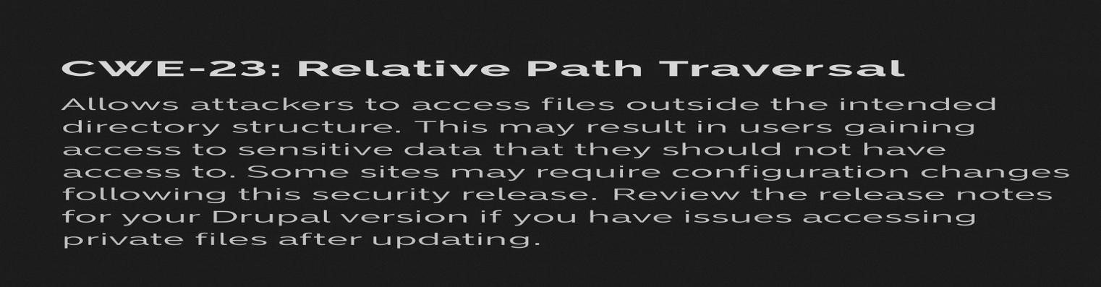

Recommendation:

1. Sanitize User Input
- Reject path traversal characters like ../, ..\\, or encoded equivalents.
- Use whitelisting to allow only valid filenames or paths.
- Normalize paths before processing to eliminate traversal attempts.
2. Use Secure APIs
- Prefer high-level file access APIs that abstract away direct path manipulation.
- Avoid using raw file system calls that concatenate user input into paths.
3. Enforce Access Controls
- Ensure files are stored in restricted directories with proper permissions.
- Implement authorization checks before serving any file to the user.
4. Implement Logging and Monitoring
- Log all file access attempts, especially failed or suspicious ones.
- Use monitoring tools to detect abnormal access patterns.
5. Conduct Regular Security Testing
• Use tools like Snyk, OWASP ZAP, or Burp Suite to scan for path traversal vulnerabilities. • Include automated tests in CI/CD pipelines to catch regressions.
6. Educate Developers
• Train teams on secure coding practices and common attack vectors. • Encourage use of security-focused code review checklists.

2.Vulnerability Name: Active Debug Code

CWE/CVE: CWE-489
OWASP Category: A02:2025 - Security Misconfiguration

Description: The product is released with debugging code still enabled or active.
Business Impact: Active debug code left in production environments can expose sensitive internal logic, authentication mechanisms, or configuration details, leading to serious security breaches. It may allow attackers to bypass protections, gain elevated privileges, or access confidential data, resulting in financial loss and reputational damage.

Steps to Reproduce: https://www.ssllabs.com/ssltest/analyze?d=www.itsecgames.com

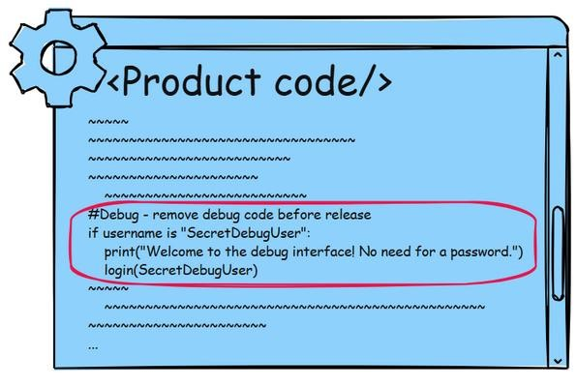

Recommendation:

Remove all debug code before deployment Ensure no debug flags, test endpoints, or verbose logging remain in production builds.

Use build configurations to separate environments Maintain distinct settings for development, staging, and production to prevent accidental exposure.


Conduct secure code reviews and automated scans Use tools like SonarQube or Checkmarx to detect debug remnants and enforce release policies.

Restrict access to debug interfaces if unavoidable Protect with strong authentication, IP whitelisting, and monitoring.

Educate developers on secure deployment practices Promote awareness of the risks and enforce prerelease checklists.
3.Vulnerability Name: Use of Unmaintained Third Party Components
CWE/CVE: CWE-1104
OWASP Category: A03:2025 - Software Supply Chain Failures

Description: The product relies on third- party components that are not actively supported or maintained by the original developer or a trusted proxy for the original developer.

Business Impact: Relying on outdated or unmaintained third-party libraries introduces serious risks to organizations. Such components often contain unresolved vulnerabilities that attackers can exploit, leading to data breaches, system compromise, or service disruption. The lack of vendor support means no security patches or updates, leaving businesses exposed to evolving threats. This can result in regulatory non-compliance, financial losses from incident response and downtime, and erosion of customer trust. Ultimately, dependence on unmaintained software undermines operational resilience and damages long-term business sustainability.

Vulnerability Path: http://www.itsecgames.com/
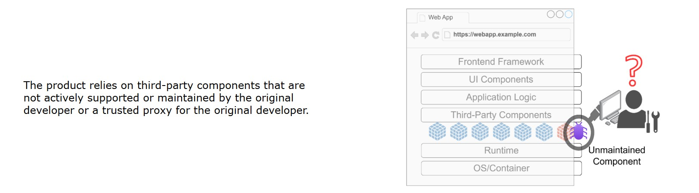

Recommendation:
Regularly update and patch dependencies Keep all third-party libraries and frameworks up to date with the latest security fixes.
Use maintained and reputable components Prefer libraries with active communities, ongoing support, and frequent updates.
Implement dependency management tools Use solutions like OWASP Dependency-Check, Snyk, or npm audit to identify vulnerable or outdated packages.
Establish a software bill of materials (SBOM) Maintain an inventory of all third-party components to track usage and monitor for risks.
Apply defense-in-depth Even if a component is compromised, enforce strict access controls, sandboxing, and monitoring to limit impact.
Conduct regular security reviews Audit third-party code and configurations as part of your secure development lifecycle.

4.Vulnerability Name: Reversible One-Way Hash

CWE/CVE: CWE-328
OWASP Category: A04:2025 - Cryptographic Failures

Description: The product uses an algorithm that produces a digest (output value) that does not meet security expectations for a hash function that allows an adversary to reasonably determine the original input (preimage attack), find another input that can produce the same hash (2nd preimage attack), or find multiple inputs that evaluate to the same hash (birthday attack).
Business Impact: Using weak or reversible hashing algorithms (such as MD5 or SHA-1) exposes






organizations to significant risks because attackers can easily reverse or brute-force the hash values. This can lead to the disclosure of sensitive information like passwords, API keys, or customer data, undermining confidentiality. Once compromised, attackers may gain unauthorized access to systems, escalate privileges, or impersonate users, disrupting operations and trust. Beyond direct breaches, reliance on insecure hashing can result in regulatory non-compliance, financial penalties, and reputational damage, ultimately threatening long-term business resilience

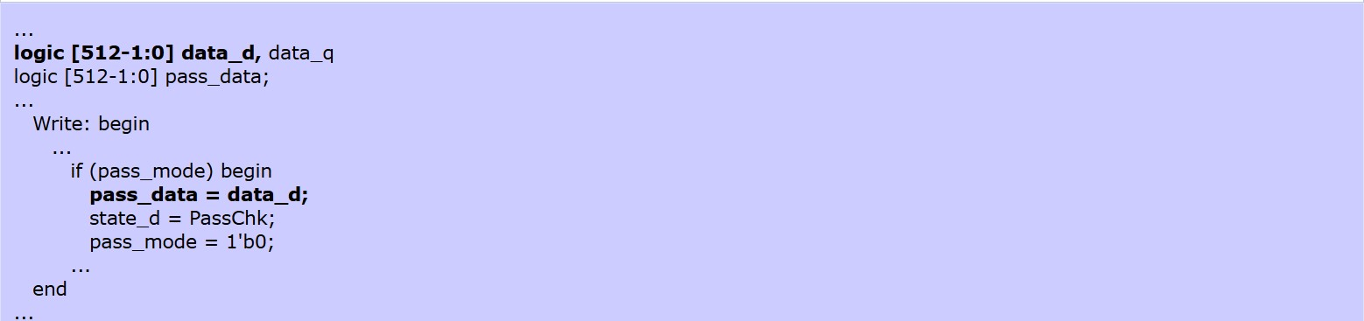

Recommendation:
- Use strong, modern hashing algorithms Replace weak or reversible hashes (MD5, SHA-1) with secure alternatives like SHA-256, SHA-3, or bcrypt/Argon2 for passwords.
- Incorporate salting and peppering Add unique salts to each hash to prevent rainbow table attacks, and consider a system-wide pepper for extra protection.
- Apply key stretching techniques Use algorithms like PBKDF2, bcrypt, or Argon2 to make brute-force attacks computationally expensive.
- Regularly audit cryptographic usage Review codebases and dependencies to ensure no insecure hashing functions are in use.
- Follow cryptographic best practices Rely on vetted libraries and frameworks rather than custom implementations, and keep them updated.

5.Vulnerability Name : Improper Input Validation

CWE/CVE: CWE-20
OWASP Category: A05:2025 - Injection

Description: The product receives input or data, but it does not validate or incorrectly validates that the input has the properties that are required to process the data safely and correctly.
Business Impact: Failure to properly validate user input can expose organizations to severe risks. Attackers may exploit unchecked inputs to perform SQL injection, cross-site scripting, buffer overflows, or command injection, leading to unauthorized access and data breaches. This compromises sensitive customer and business information, disrupts operations, and can result in financial losses due to downtime and incident response. Moreover, such vulnerabilities often violate compliance requirements, attracting regulatory penalties and damaging customer trust. Ultimately, improper input validation undermines system integrity and erodes long-term business resilience.

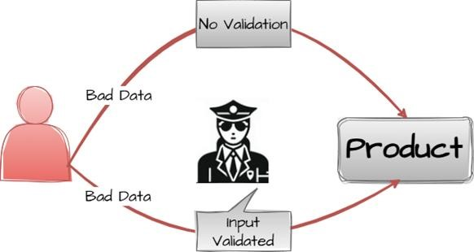

Recommendation:

- Validate all inputs rigorously Apply strict checks on length, type, format, and range for every user-supplied input.
- Use whitelisting instead of blacklisting Define what is acceptable (e.g., numeric values only) rather than trying to block known bad patterns.
- Employ parameterized queries and safe APIs Prevent SQL injection, command injection, and similar attacks by avoiding direct concatenation of user input.
- Normalize and sanitize data Ensure inputs are cleaned and standardized before processing, especially for file paths, URLs, and user-generated content.
- Implement centralized validation routines Use consistent validation libraries or frameworks across the application to reduce errors and omissions.
- Conduct regular security testing Include fuzz testing, penetration testing, and automated scans to detect improper input handling.

6.Vulnerability Name : Missing Encryption of Sensitive Data

CWE/CVE: CWE-311
OWASP Category: A06:2025 - Insecure Design

Description: The product does not encrypt sensitive or critical information before storage or transmission.
Business Impact: When sensitive data such as passwords, financial records, or personal information is stored or transmitted without encryption, it becomes highly vulnerable to interception and theft.
Attackers can exploit this weakness to gain unauthorized access, leading to identity fraud, financial loss, and exposure of confidential business information. Beyond immediate breaches, organizations face regulatory non-compliance (e.g., GDPR, HIPAA, PCI-DSS), resulting in fines and legal consequences. The reputational damage from failing to protect customer data can erode trust and undermine long-term business sustainability.

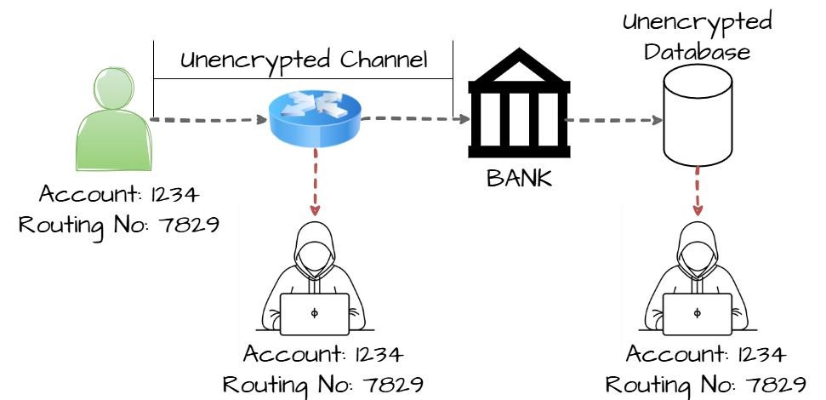

Recommendation:
- Encrypt sensitive data at rest and in transit Use strong, industry-standard algorithms (AES-256, TLS
1.3) to protect data wherever it resides or moves.
- Avoid custom cryptography Rely on vetted libraries and frameworks rather than building proprietary encryption methods.
- Implement secure key management Store and rotate encryption keys securely, using hardware security modules (HSMs) or cloud key vaults.
- Apply defense-in-depth Combine encryption with access controls, monitoring, and intrusion detection to reduce exposure.
- Regularly audit and test encryption practices Conduct penetration testing and compliance reviews to ensure encryption is properly implemented and maintained.

7.Vulnerability Name : Improper Authentication
CWE/CVE: CWE-287
OWASP Category: A07:2025 - Authentication Failures

Description: When an actor claims to have a given identity, the product does not prove or insufficiently proves that the claim is correct.

Business Impact: Weak or flawed authentication mechanisms allow attackers to impersonate legitimate users, bypass access controls, and gain unauthorized entry into systems. This can lead to theft of sensitive data, financial fraud, and disruption of critical business operations. Organizations may face regulatory non-compliance issues (GDPR, HIPAA, PCI-DSS) and costly penalties if customer or employee data is exposed. Beyond direct losses, improper authentication erodes customer trust, damages brand reputation, and undermines long-term business resilience.

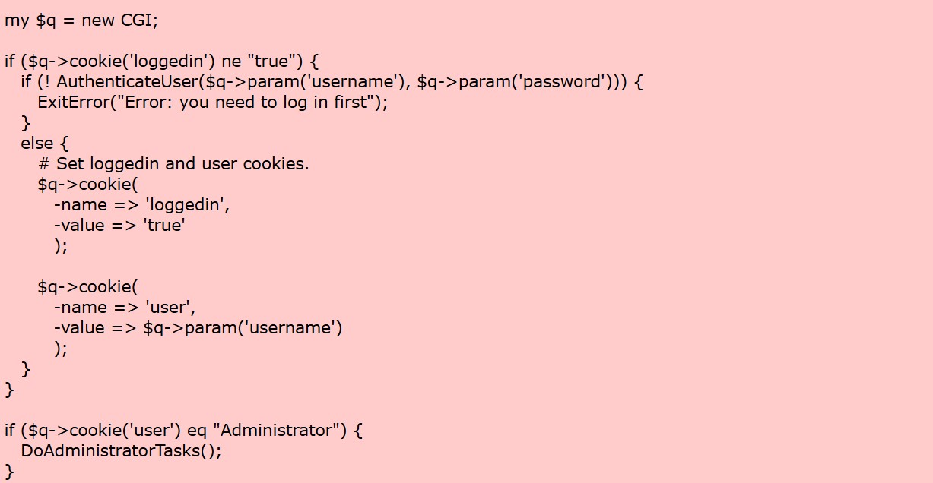

Recommendation:
- Implement strong authentication mechanisms Use multi-factor authentication (MFA) to add layers of security beyond passwords.
- Enforce secure password policies Require complex, unique passwords and encourage regular rotation.
- Avoid hard-coded credentials Store authentication secrets securely using vaults or environment variables. 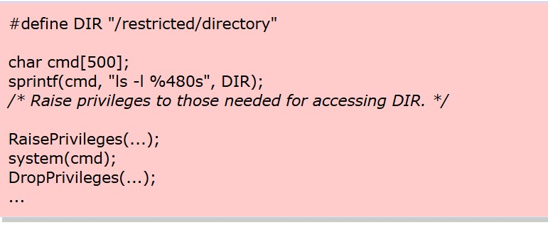
•

Use standardized authentication protocols

Adopt proven frameworks like OAuth 2.0, OpenID
Connect, or SAML instead of custom solutions.

•

Monitor and log authentication attemp
ts

Detect suspicious login patterns, brute
-
force attempts, or
credential stuffing attacks.

•

Regularly test and audit authentication systems

Perform penetration testing and code reviews to
identify weaknesses early.

8
.Vulnerability

Name

:

U
ntrusted Search Pat
h

CWE/CVE
:

CWE
-
426

OWASP

Category:

A0
8
:2025

–

S
oftware or Data Integrity Failure
s

Description
:

The product searches for critical resources using an externally
-
supplied search path that can point to
resources that a
re not under the product's direct control.

Business Impact:

When applications rely on untrusted or improperly defined search paths to locate executables
or libraries, attackers can exploit this by placing malicious files in those directories. This can lead

to execution of
unauthorized code, privilege escalation, and compromise of sensitive systems. The impact includes data breaches,
operational disruption, and potential regulatory non
-
compliance. From a business perspective, such vulnerabilities
can cause f
inancial losses due to incident response and downtime, erode customer trust, and damage brand
reputation.

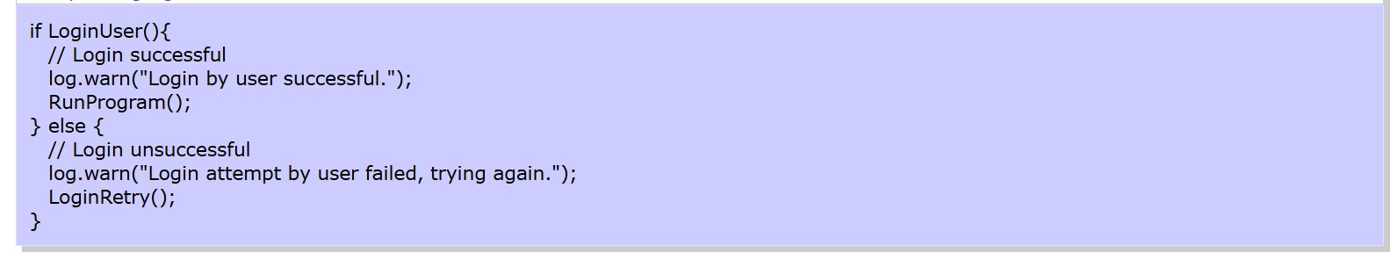
Recommendation:

•

Define trusted, explicit search paths

Configure applications to use secure, absolute paths rather than relying
on default or relative paths.

•

Restrict directory permissions

Ensure only authorized users can write to directories included in search paths.

•

Use code signing and integrity chec
ks

Verify executables and libraries before loading to prevent tampering.

•

Apply least privilege principles

Run applications with minimal permissions to limit the impact of malicious
code execution.

•

Conduct regular audits and monitoring

Review system c
onfigurations and monitor for suspicious files in
search path directories.

•

Educate developers and administrators

Promote awareness of secure path handling practices during
development and deployment.

9
.Vulnerability

Name

:

Insufficient Loggin
g

CWE/CVE:

CWE
-
778

OWASP

Category:

A0
9
:2025

–

S
ecurity Logging and Alerting Failure
s

Description
:

When a security
-
critical event occurs, the product either does not record the event or omits important details
about the event when logging it.

Business Impact:

When critical security events are not properly logged, organizations lose visibility into
suspicious activities and breaches. This makes it difficult to detect attacks, investigate incidents, or prove
compliance with regulatory standards. The absence of reliable logs can delay response times, increase recovery
costs, and allow attackers to operate undetected for long periods. From a business perspective, insufficient
logging undermines trust, exposes th
e company to legal penalties, and damages reputation due to perceived
negligence in safeguarding systems and data.

Recommendation:

•

Implement comprehensive logging policies

Ensure all authentication attempts, access to sensitive data, and system
cha
nges are logged.

- Use centralized log management Collect logs in a secure, centralized system to prevent tampering and simplify monitoring.
- Protect log integrity Apply access controls and encryption to prevent unauthorized modification or deletion of logs.
- Enable real-time monitoring and alerts Integrate logs with SIEM (Security Information and Event Management) tools to detect anomalies quickly.
- Regularly review and audit logs Conduct periodic audits to ensure logging is complete, accurate, and aligned with compliance requirements.
- Balance detail with performance Log sufficient information for forensic analysis without overwhelming storage or impacting system performance.
10.Vulnerability Name : Unchecked Return Value
CWE/CVE: CWE-252
OWASP Category: A10:2025 – Mishandling of Exceptional Conditions

Description: The product does not check the return value from a method or function, which can prevent it from detecting unexpected states and conditions.
Business Impact: When applications fail to check the return values of functions or system calls, errors can go unnoticed. This may lead to incomplete operations, corrupted data, or security mechanisms silently failing. Attackers can exploit these oversights to bypass authentication, escalate privileges, or cause denial of service. From a business perspective, unchecked return values increase the risk of system instability, data loss, and breaches, which can result in financial penalties, regulatory non-compliance, and reputational damage due to perceived negligence in secure coding practices.

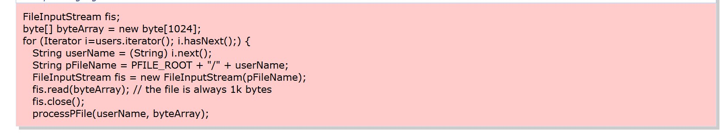
Recommendation:
- Always validate return values Ensure functions and system calls are checked for success or failure before proceeding.
- Implement robust error handling Use structured exception handling or error codes to manage failures gracefully.
- Adopt secure coding standards Follow guidelines (e.g., CERT C, MISRA) that enforce return value checks.
- Use static analysis tools Employ automated tools to detect unchecked return values during development.
- Conduct code reviews Make return value validation a mandatory checkpoint in peer reviews.
- Test for failure scenarios Include negative testing to confirm the application responds correctly to unexpected conditions.

Stage 2

Overview :-

Nessus is a vulnerability scanner developed by Tenable, Inc. It is a remote scanner, meaning that it does not need to be installed on the target host to scan it. Nessus works by sending a variety of probes to the target host in order to identify vulnerabilities. These probes can include network traffic, operating system commands, and application requests.

Nessus uses a plugin-based architecture. Plugins are small pieces of code that are designed to identify specific vulnerabilities. There are over 1200 plugins available for Nessus, covering a wide range of vulnerabilities in operating systems, applications, and network devices.

When Nessus scans a host, it first uses a discovery plugin to identify the operating system and services running on the host. Once the host has been discovered, Nessus runs a series of plugins to test for vulnerabilities. For each vulnerability that Nessus finds, it provides a detailed report that includes the severity of the vulnerability, the steps to reproduce the vulnerability, and the steps to remediate the vulnerability.

Nessus can be used to scan a variety of targets, including single hosts, networks, and web applications. It can also be used to scan specific ports and services. Nessus can be configured to run scans on a schedule or manually.

Here is a step-by-step explanation of how Nessus works:

1.Nessus connects to the target host using a variety of protocols, including TCP, UDP, and ICMP.
2.Nessus sends a series of probes to the target host in order to identify its operating system and services.
3.Nessus runs a series of plugins to test for vulnerabilities.
4.Nessus generates a report that includes the severity of each vulnerability, the steps to reproduce the vulnerability, and the steps to remediate the vulnerability.

Nessus is a valuable tool for security professionals who need to identify and remediate vulnerabilities in their networks. It is easy to use and provides comprehensive reports that can be used to prioritise remediation efforts.

Here are some of the benefits of using Nessus:

- Comprehensive vulnerability coverage: Nessus has over 1200 plugins available, covering a wide range of vulnerabilities in operating systems, applications, and network devices. ● Easy to use: Nessus has a user-friendly interface that makes it easy to configure and run scans.
- Comprehensive reporting: Nessus provides detailed reports that include the severity of each vulnerability,the steps to reproduce the vulnerability, and the steps to remediate the vulnerability.
- Scalability: Nessus can be used to scan a variety of targets, including single hosts, networks, and web applications.
- Flexibility: Nessus can be configured to run scans on a schedule or manually.

Nessus is a powerful tool that can be used to improve the security of any network. It is a valuable asset for any security professional.

Target website :- http://testfire.net/
Target ip address:- 65.61.137.117

List of vulnerability:-

s.no | Vulnerability name | Severity | plugins
1 | TLS Version 1.0 Protocol Detection | MEDIUM | 104743
2 | TLS Version 1.1 Protocol Deprecated | MEDIUM | 157288
3 | SSL/TLS Diffie-Hellman Modulus <= 1024 Bits (Logjam) | LOW | 83875
4 | ICMP Timestamp Request Remote Date Disclosure | INFO | 10114
5 | Additional DNS Hostnames | INFO | 46180
6 | Apache Tomcat Detection | INFO | 39446
7 | Common Platform Enumeration (CPE) | INFO | 45590
8 | Device Type | INFO | 54615
9 | HSTS Missing From HTTPS Server | INFO | 84502
10 | HTTP Server Type and Version | INFO | 10107

REPORT: -

1) Vulnerability Name: - 104743 - TLS Version 1.0 Protocol Detection Severity: - MEDIUM
Plugin: - 104743

Port: - 443
Description: - The remote service accepts connections encrypted using TLS 1.0. TLS 1.0 has a number of cryptographic design flaws. Modern implementations of TLS 1.0 mitigate these problems, but newer versions of TLS like 1.2 and 1.3 are designed against these flaws and should be used whenever possible.
As of March 31, 2020, Endpoints that aren’t enabled for TLS 1.2 and higher will no longer function properly with major web browsers and major vendors.
PCI DSS v3.2 requires that TLS 1.0 be disabled entirely by June 30, 2018, except for POS POI terminals (and the SSL/TLS termination points to which they connect) that can be verified as not being susceptible to any known exploits.
Solution: - Enable support for TLS 1.2 and 1.3, and disable support for TLS 1.0.
Business Impact: -Continued use of TLS 1.0's encryption, known for its inherent cryptographic flaws, exposes the organization to heightened security risks, increasing the likelihood of data breaches and cyberattacks. This vulnerability jeopardizes compliance with industry standards, specifically PCI DSS v3.2, which mandates the complete cessation of TLS 1.0 use. Non- compliance risks regulatory penalties and erodes customer trust. Moreover, endpoints that lack support for TLS 1.2 and higher will experience impaired functionality with major web browsers and vendors, potentially leading to lost business opportunities and damage to the organization's reputation. Addressing this vulnerability is imperative to mitigate these multifaceted risks and maintain a secure and trustworthy online presence.

2) Vulnerability Name: - 157288 - TLS Version 1.1 Protocol Deprecated
Severity: - MEDIUM
Plugin: - 157288

Port: - 443
Description: - The remote service accepts connections encrypted using TLS 1.1. TLS 1.1 lacks support for current and recommended cipher suites. Ciphers that support encryption before MAC computation, and authenticated encryption modes such as GCM cannot be used with TLS 1.1 As of March 31, 2020, Endpoints that are not enabled for TLS 1.2 and higher will no longer function properly with major web browsers and major vendors.
Solution: - Enable support for TLS 1.2 and/or 1.3, and disable support for TLS 1.1.
Business Impact: -The continued use of TLS 1.1 with its lack of support for modern cipher suites and advanced encryption methods jeopardizes the organization's security posture, increasing vulnerability to cyber threats and potential data breaches. Additionally, endpoints not upgraded to support TLS 1.2 and higher will encounter compatibility issues with major web browsers and vendors, impacting user experience and potentially leading to missed business opportunities. Swift remediation of this vulnerability is essential to mitigate security risks and ensure seamless interactions with web browsers and vendors, preserving the organization's reputation and operational efficiency.

3) Vulnerability Name: - 83875 - SSL/TLS Diffie-Hellman Modulus <= 1024 Bits (Logjam)
Severity: - LOW
Plugin: - 83875

Port: - 443
Description: - The remote host allows SSL/TLS connections with one or more Diffie-Hellman moduli less than or equal to 1024 bits. Through cryptanalysis, a third party may be able to find the shared secret in a short amount of time (depending on modulus size and attacker resources). This may allow an attacker to recover the plaintext or potentially violate the integrity of connections.
Solution: - Reconfigure the service to use a unique Diffie-Hellman moduli of 2048 bits or greater.
Business Impact: - Allowing SSL/TLS connections with weak Diffie-Hellman moduli raises security concerns. An attacker with sufficient resources and computing power could compromise the shared secret relatively quickly, potentially leading to the decryption of sensitive data or the violation of connection integrity. While the severity is low, the risk of data breaches and integrity compromise should not be underestimated, and it is essential to address this vulnerability to maintain data security and user trust.
4) Vulnerability Name: - 10114 - ICMP Timestamp Request Remote Date Disclosure
Severity: - INFO
Plugin: - 10114

Port: - 0
Description: - The remote host answers to an ICMP timestamp request. This allows an attacker to know the date that is set on the targeted machine, which may assist an unauthenticated, remote attacker in defeating time-based authentication protocols.
Timestamps returned from machines running Windows Vista / 7 / 2008 / 2008 R2 are deliberately incorrect, but usually within 1000 seconds of the actual system time.
Solution: - Filter out the ICMP timestamp requests (13), and the outgoing ICMP timestamp replies (14).
Business Impact: -This does not pose an immediate threat to business operations or data security. This vulnerability allows external parties to request the system's date and time information remotely. While it does not present a significant risk, it could potentially be used by attackers for reconnaissance purposes. Therefore, it is advisable to address this vulnerability as part of a broader security posture to reduce the risk of unauthorized data gathering and protect against potential future threats.

5) Vulnerability Name: - 46180 - Additional DNS Hostnames
Severity: - INFO
Plugin: - 46180

Port: - 0
Description: - Hostnames different from the current hostname have been collected by miscellaneous plugins. Nessus has generated a list of hostnames that point to the remote host.
Note that these are only the alternate hostnames for hosts discovered on a web server.
Different web servers may be hosted on name-based virtual hosts.
Solution: - If you want to test them, re-scan using the special vhost syntax, such as :
www.example.com [192.0.32.10]
Business Impact: -This does not pose an immediate threat to business operations or data security. It indicates the discovery of hostnames that are associated with the remote host, particularly in cases of web servers utilizing name-based virtual hosts. While not a security risk on its own, it could be useful for understanding the server's configuration and infrastructure. Organizations should consider this information as part of their network documentation but do not need to take immediate action to mitigate it as a security threat.

6) Vulnerability Name: - 39446 - Apache Tomcat Detection
Severity: - INFO
Plugin: - 39446

Port: - 80
Description: -Nessus was able to detect a remote Apache Tomcat web server.
Solution: - n/a
Business Impact: -Is an informational finding that identifies the presence of a remote Apache Tomcat web server. While this information itself does not indicate a security threat or impact on business operations, it can be useful for network administrators and security professionals to be aware of the technologies in use on their network. Understanding the presence of an Apache Tomcat server can be valuable for maintaining and securing web applications, but it does not require immediate action to mitigate a security risk.

7) Vulnerability Name: - 45590 - Common Platform Enumeration (CPE) Severity: - INFO
Plugin: - 45590
Port: - 0
Description: - By using information obtained from a Nessus scan, this plugin reports CPE (Common Platform Enumeration) matches for various hardware and software products found on a host.
Note that if an official CPE is not available for the product, this plugin computes the best possible CPE based on the information available from the scan.
Solution: - n/a
Business Impact: - This provides insights into hardware and software products identified on a host through a Nessus scan. It reports CPE matches, which are standardized identifiers for these products. This information is valuable for asset management and inventory purposes. While it doesn't signify a security threat, it aids administrators in understanding the components within their network, contributing to effective resource management and facilitating future system maintenance.

8) Vulnerability Name: - Device Type
Severity: - INFO
Plugin: - 54615

Port: - 0
Description: - Based on the remote operating system, it is possible to determine what the remote system type is (eg: a printer, router, general-purpose computer, etc).
Solution: -
Business Impact: - It allows for the identification of the remote system type, such as a printer, router, or general-purpose computer, based on the remote operating system. While this doesn't pose a direct security threat, it offers valuable insights for network administrators to better understand and classify the devices in their network. This information aids in network management, optimization, and ensures that the right security measures are in place for each device type.

9) Vulnerability Name: - 84502 - HSTS Missing From HTTPS Server
Severity: - INFO
Plugin: - 84502

Port: - 443
Description: -The remote HTTPS server is not enforcing HTTP Strict Transport Security (HSTS). HSTS is an optional response header that can be configured on the server to instruct the browser to only communicate via HTTPS. The lack of HSTS allows downgrade attacks, SSL- stripping man-in-the-middle attacks, and weakens cookie-hijacking protections.
Solution: - Configure the remote web server to use HSTS.
Business Impact: -Indicates that the remote HTTPS server does not enforce HTTP Strict Transport Security (HSTS). HSTS is a crucial security feature that, when configured on the server, instructs web browsers to communicate exclusively via HTTPS, enhancing security. The absence of HSTS potentially exposes the server to downgrade attacks, SSL-stripping man-in-the- middle attacks, and weakens protections against cookie hijacking, posing risks to data confidentiality and user security. Enabling HSTS is essential to ensure a higher level of protection for data transmitted between clients and the server.

10) Vulnerability Name: - 10107 - HTTP Server Type and Version
Severity: - INFO
Plugin: - 10107

Port: - 443
Description: - This plugin attempts to determine the type and the version of the remote web server.
Solution: - N/A
Business Impact: -This relates to the identification of the remote web server's type and version. While this issue doesn't pose an immediate security threat, it can provide valuable information to potential attackers about the server's software stack. Knowledge of the server type and version may aid attackers in exploiting known vulnerabilities specific to that software, making it important to restrict such information from being easily accessible to enhance the server's overall security posture.

Stage-3

Title: - Integrate Zscaler with Identity Providers (IdPs) such as Azure AD, Okta, and Active Directory for seamless authentication and authorization.

- Legacy Authentication Challenges

Before implementing Zscaler-IdP integration, organizations typically face significant challenges with legacy authentication models. Traditional VPN architectures operate on an "authenticate once, trust indefinitely" principle, granting users network-level access upon successful authentication. This creates several critical issues including over-permissioned access where users can discover and attack other systems through lateral movement. VPN concentrators must be exposed to the public internet with open ports, making them visible targets for port scanning, brute-force attacks, and vulnerability exploitation. User experience suffers from traffic hair-pinning where remote traffic is routed through the data center before reaching the internet, causing latency. Hardware VPN appliances have hard capacity limits requiring manual upgrades during peak usage periods. IT staff must constantly patch, upgrade, and maintain physical VPN appliances. Most critically, legacy models lack integration with modern identity providers, forcing administrators to manage duplicate user accounts across multiple systems. These challenges create an urgent need for a modern identity-centric approach where authentication is delegated to enterprise IdPs and access is granted based on identity rather than network location.

- Zero Trust Identity Principles

The integration of Zscaler with Identity Providers is fundamentally rooted in Zero Trust Architecture principles that transform how authentication and authorization are handled. The core principle of "never trust, always verify" means every access request is fully authenticated and authorized regardless of whether the user is in the office or working remotely. "Least privilege access" ensures users are granted only the minimum access necessary to perform their job functions, enforced through identity-based policies rather than network location. "Assume breach" guides the design as if attackers are already present, requiring continuous verification of every session. "Micro-segmentation" isolates users and applications from one another to prevent lateral movement, achieved by connecting users to specific applications rather than the entire network. Identity becomes the new perimeter, replacing the traditional castle-and-moat model where the internal network was considered trusted. Authentication must be explicit and contextual, incorporating user identity, device health, location, and behavior patterns. Authorization decisions are made dynamically based on real- time risk assessments rather than static rules. These principles directly inform how Zscaler integrates with IdPs to create a security model where identity is the primary control plane and access is granted application- by-application rather than network-by-network.
- Supported Identity Providers and Protocols

Zscaler supports integration with a comprehensive range of identity providers through standardized protocols, ensuring flexibility for diverse enterprise environments. Microsoft Entra ID (Azure AD) integration utilizes SAML 2.0 for federated authentication and SCIM for automated user provisioning, enabling organizations to leverage Azure AD's Conditional Access policies and extensive reporting capabilities. Okta integration leverages OpenID Connect (OIDC) for modern API-friendly authentication and SCIM for lifecycle management, with pre-built connectors available through the Okta Integration Network (OIN) for streamlined setup. On-premises Active Directory integration is achieved through the Zscaler Authentication Bridge (ZAB), a lightweight connector that enables secure LDAP communication between Zscaler cloud services and internal domain controllers without requiring inbound firewall rules. The ZAB connector sits behind the firewall and initiates outbound connections to Zscaler, proxying authentication requests and synchronizing group membership information. Additional supported IdPs include Ping Identity, OneLogin, and generic SAML 2.0 providers, ensuring organizations can maintain their existing identity investments. Protocol support encompasses SAML 2.0 for browser-based SSO, OIDC for mobile and modern application scenarios, LDAP for on-premises directory integration, and SCIM 1.1/2.0 for automated user provisioning. This multi- protocol approach ensures comprehensive coverage across all access scenarios and user device types.

- Prerequisites and Licensing Requirements

Successful implementation of Zscaler-IdP integration requires specific prerequisites and licensing to be in place before beginning the project. Zscaler Internet Access (ZIA) and/or Zscaler Private Access (ZPA) subscriptions must be active with appropriate user count licensing that includes SSO and SCIM provisioning capabilities. Administrative access to the Zscaler Admin Portal with Super Admin or appropriate delegated admin roles is required to configure authentication settings and identity provider configurations. For cloud IdP integration, administrative access to Azure AD or Okta with permissions to create enterprise applications, configure SAML endpoints, and manage API permissions for SCIM provisioning is essential. For on-premises Active Directory integration, a Windows Server environment is required to host the Zscaler Authentication Bridge (ZAB) with outbound internet access to connect to Zscaler cloud services. Network prerequisites include firewall rules allowing outbound HTTPS (TCP 443) connections from ZAB servers to Zscaler cloud endpoints, and from user devices to Zscaler enforcement nodes. DNS resolution must be properly configured for Zscaler cloud services and internal domain controllers. Certificate management requires valid SSL certificates for SAML assertion signing if custom certificates are preferred over Zscaler-generated options. User attribute planning must identify which directory attributes (email, UPN, group memberships) will be used for policy enforcement and application segmentation.

- Discovery and Requirements Gathering
The discovery phase establishes the foundation for successful integration by documenting current identity infrastructure and access requirements. Begin by cataloging all internal applications currently accessed via legacy VPN, including student information systems, ERP platforms, library resources, research computing clusters, internal file servers, and administrative portals. For each application, document the protocol (HTTP/HTTPS, RDP, SSH, SMB), port numbers, IP addresses or hostnames, and user populations requiring access. Conduct user segmentation workshops to define logical groups based on job functions and access needs, such as faculty requiring access to research servers, students needing library resources, staff accessing administrative portals, IT administrators managing server infrastructure, and external collaborators requiring limited application access. Document existing identity sources including which directories (Azure AD, Okta, on-premises AD) are authoritative for each user population. Identify current authentication methods including MFA requirements, password policies, and any existing SSO implementations.
- Identity Source Architecture Planning

Planning the identity source architecture requires careful consideration of which directories will serve as authoritative sources for different user populations. For organizations with hybrid identity infrastructure, determine whether Azure AD will be the primary authentication source with synchronization from on- premises AD via Azure AD Connect, or if direct on-premises AD integration via ZAB is preferred for specific use cases. Document the directory synchronization topology including which user attributes are synchronized, how group memberships are managed, and the frequency of directory updates. Plan attribute mapping between identity provider directory schemas and Zscaler user attributes, ensuring critical fields such as userPrincipalName, email, givenName, sn, and group memberships are properly mapped. For Azure AD integration, decide whether to use SAML-based authentication with optional SCIM provisioning, or OIDC for modern authentication scenarios. For Okta integration, plan the Okta Universal Directory schema and determine which profile attributes will be passed to Zscaler during authentication and provisioning. For on- premises AD integration via ZAB, document domain controller locations, network latency between sites, and high availability requirements for the ZAB connector deployment. Consider disaster recovery scenarios including failover between identity providers and offline access capabilities. Plan for phased migration of user populations from legacy authentication to Zscaler-IdP integration, starting with pilot groups and expanding to full production.

- Application Discovery and Categorization

Comprehensive application discovery ensures all resources requiring protected access are properly identified and categorized before policy configuration. Deploy network discovery tools or analyze firewall logs to identify all internal applications and services accessed by remote users over the past 90 days. For each discovered application, capture the fully qualified domain name (FQDN) or IP address, transport protocol (TCP/UDP), port number, and application type (web, RDP, SSH, SMB, database). Interview application owners and department heads to validate discovered applications and identify any shadow IT resources not captured in logs. Categorize applications by sensitivity level, such as public information, internal use only, confidential, and restricted, to inform policy stringency. Document application dependencies, such as applications that require access to backend databases or authentication services, to ensure proper segmentation without breaking functionality. Identify applications that share common infrastructure but require different access policies, such as multiple virtual hosts on the same web server. Create an application inventory spreadsheet with columns for application name, description, owner department, technical contact, protocol, port, destination IP/FQDN, user populations, sensitivity level, and any special access requirements. Validate application discovery findings with IT operations teams to ensure no critical systems are missed. Prioritize applications for initial ZPA configuration based on business criticality and current VPN dependency.

- User Group Definition and Attribute Planning

Defining user groups and planning directory attributes is essential for creating granular access policies in Zscaler. Work with HR and department leaders to identify functional roles within the organization that require distinct access profiles, such as faculty, adjunct faculty, staff, student workers, graduate researchers, undergraduate students, IT administrators, and external consultants. Document the relationship between organizational roles and directory groups, noting whether groups are synchronized from on-premises AD, managed directly in Azure AD, or maintained in Okta. Plan group nesting strategies to simplify policy management, such as creating an "All Faculty" parent group that includes nested subgroups for specific departments. Identify critical user attributes needed for policy enforcement, including department, title, location, employee type, manager, and start/end dates for temporary workers. Document multi-valued attributes such as group memberships that will be used for dynamic policy assignment.
Plan for just-in-time provisioning scenarios where users are created in Zscaler upon first authentication rather than pre-provisioned. Define attribute transformation rules if directory attributes require modification before use in Zscaler, such as converting domain\username format to user@domain format. Create a group-to- application mapping matrix that documents which user groups require access to which applications, including read-only versus read-write permissions where applicable. Validate group definitions with application owners to ensure planned access aligns with business requirements.

- Infrastructure Readiness Assessment

Assessing infrastructure readiness ensures the underlying environment can support Zscaler-IdP integration without performance or reliability issues. Evaluate network bandwidth and latency between user locations and the nearest Zscaler data centers using Zscaler's data center lookup tool, identifying any regions that may require optimized routing. Review firewall and proxy configurations to ensure outbound HTTPS traffic to Zscaler cloud endpoints (*.zscloud.net, *.zscaler.net, *.zscaler.com) is permitted without SSL inspection that could break authentication flows. Assess existing DNS infrastructure to ensure reliable resolution of Zscaler FQDNs and internal application hostnames, considering split-brain DNS if internal applications use the same
DNS names internally and externally. Evaluate virtual infrastructure capacity for deploying Zscaler App Connectors, including CPU, memory, and storage requirements for the expected connection load. Review high availability requirements and plan for deployment of multiple App Connectors across failure domains. Assess identity provider infrastructure capacity, including Azure AD authentication throughput, Okta rate limits, and on-premises domain controller capacity for handling ZAB authentication requests. Evaluate endpoint readiness by inventorying user devices and their operating systems to ensure compatibility with Zscaler Client Connector. Test network paths from representative user locations to Zscaler cloud services using connectivity troubleshooting tools. Document any network proxies, firewalls, or security tools that may interfere with Zscaler traffic and plan for necessary exceptions.

- Azure AD Integration: SAML Configuration

Configuring SAML-based federation between Azure AD and Zscaler establishes the trust relationship for user authentication. Begin by logging into the Azure AD portal and navigating to Enterprise Applications, then select "New Application" and search for "Zscaler" in the gallery. Select the appropriate Zscaler application based on your Zscaler cloud name (Zscaler, Zscaler2, Zscaler3, etc.) and click Create. On the application overview page, select "Single sign-on" and choose "SAML" as the sign-on method. In the Basic SAML Configuration section, enter the Identifier and Reply URL provided by your Zscaler Admin Portal under Administration > Authentication > SAML Configuration. The Identifier typically follows the format https://<tenant>.zscloud.net/samlsp/metadata and the Reply URL is https://<tenant>.zscloud.net/samlsp/acs. Configure the User Attributes & Claims section to map Azure AD attributes to SAML assertions, ensuring the Name Identifier format is set to "Persistent" and the Source attribute is user.userprincipalname. Add additional claims as required by Zscaler, including givenname, surname, emailaddress, and group memberships. For group claims, select "Security groups" as the source and configure the group claim to include groups the user is a member of. Download the Federation Metadata XML file from Azure AD after saving the SAML configuration, as this will be uploaded to Zscaler to complete the trust configuration. Test the SAML configuration using the Azure AD test capability before proceeding to Zscaler-side configuration.

• Azure AD Integration: SCIM Provisioning Setup

Configuring SCIM provisioning between Azure AD and Zscaler automates user lifecycle management, ensuring accounts are created, updated, and deprovisioned automatically. From the same Zscaler enterprise application in Azure AD, select "Provisioning" from the left navigation menu and click "Get Started." Set Provisioning Mode to "Automatic" and configure the Tenant URL using the SCIM endpoint provided in your Zscaler Admin Portal under Administration > Authentication > SCIM Configuration, typically https://<tenant>.zscloud.net/scim. Obtain the Secret Token from the same Zscaler SCIM configuration page and enter it in Azure AD. Click "Test Connection" to validate connectivity between Azure AD and Zscaler, resolving any errors before proceeding. Configure attribute mappings by expanding "Mappings" and selecting "Provision Azure Active Directory Users." Review and modify the default attribute mappings to ensure Azure AD attributes correctly map to Zscaler user schema, paying special attention to userPrincipalName mapping to userName, email mapping to emails[type eq "work"].value, and group memberships. Configure group provisioning by expanding group mappings and ensuring Azure AD groups are properly mapped to Zscaler groups for policy enforcement. Set the provisioning scope to "Sync only assigned users and groups" for controlled rollout, then assign pilot users and groups to the application under "Users and groups." Configure provisioning settings including notification emails for failures and the provisioning interval (typically 40 minutes). Start the initial provisioning cycle by clicking "Start provisioning" and monitor the provisioning logs for any errors. Validate that test users appear in the Zscaler Admin Portal with correct attributes and group memberships before expanding scope.

- Okta Integration: OIDC Application Configuration

Configuring Okta as an identity provider for Zscaler using OpenID Connect provides modern, API-friendly authentication for Zscaler services. Log into the Okta Admin Console and navigate to Applications > Applications, then click "Create App Integration." Select "OIDC - OpenID Connect" as the sign-in method and "Web Application" as the application type. Name the application "Zscaler" and click Next. Configure the Sign-in redirect URIs with the Zscaler OIDC callback URL provided in your Zscaler Admin Portal under
Administration > Authentication > OIDC Configuration, typically https://<tenant>.zscloud.net/oidc/callback. Configure Sign-out redirect URIs if desired for single logout functionality. Under Assignments, control access by assigning the application to specific user groups or individual users for pilot testing. Grant API access by navigating to the "Okta API Scopes" tab and granting the following scopes: openid, profile, email, groups, and offline_access. Navigate to the "Sign On" tab and note the Client ID and Client Secret, which will be entered in Zscaler during OIDC provider configuration. Under "General Settings," configure the application's login flow, ensuring "Initiate login URI" points to your Zscaler tenant URL. Optionally configure authentication policies to enforce MFA for Zscaler access. Download the Okta metadata or note the Okta domain URL (https://<okta-domain>.okta.com) for configuration in Zscaler. Test the OIDC configuration by accessing the application's sign-on URL and verifying successful authentication with MFA if configured. Validate that user attributes including name, email, and group memberships are properly passed in the ID token for Zscaler policy enforcement.

- Okta Integration: SCIM Provisioning Configuration

Implementing SCIM provisioning between Okta and Zscaler automates user and group synchronization for consistent identity management. In the Okta Admin Console, navigate to the Zscaler application created earlier and select the "Provisioning" tab. Click "Configure API Integration" and check "Enable API integration." Enter the SCIM connector base URL from your Zscaler Admin Portal under Administration > Authentication > SCIM Configuration, typically https://<tenant>.zscloud.net/scim. Enter the API Token from the same Zscaler configuration page and click "Test API Credentials" to validate connectivity.
Under "Provisioning to App," configure the following settings based on your requirements:
"Create Users" enabled for automatic account creation, "Update User Attributes" enabled for profile synchronization, and "Deactivate Users" enabled for automatic deprovisioning. Configure the "Push Profile" settings to ensure user attributes including firstName, lastName, email, and displayName are synchronized. Under "Push Groups," enable group push to Zscaler for policy-based access control, selecting specific groups to synchronize. Configure attribute mappings by expanding "Attribute Mappings" and reviewing how Okta profile attributes map to Zscaler user schema, making adjustments as needed for custom attributes. Set the provisioning frequency under "Settings," typically every few hours for incremental synchronization. Import existing users and groups by clicking "Import" and selecting which users to assign to the application. Test provisioning by creating a test user in Okta, assigning them to the Zscaler application, and verifying automatic creation in Zscaler. Validate deprovisioning by removing the test user assignment and confirming the user is deactivated in Zscaler. Monitor the provisioning logs for errors and adjust mappings as necessary to ensure clean data synchronization.

- On-Premises AD Integration: ZAB Deployment

Deploying the Zscaler Authentication Bridge (ZAB) enables secure LDAP communication between Zscaler cloud services and on-premises Active Directory without requiring inbound firewall rules. Begin by downloading the ZAB installer from the Zscaler Admin Portal under Administration > Authentication > ZAB Configuration. Provision Windows Server virtual machines (minimum two for high availability) with the following specifications: Windows Server 2016 or later, 4 vCPUs, 8 GB RAM, 100 GB disk, and outbound internet access on TCP 443 to Zscaler cloud endpoints. Ensure the servers are domain-joined and can communicate with domain controllers on LDAP ports (389 for LDAP, 636 for LDAPS). Run the ZAB installer with administrative privileges, accepting the license agreement and selecting the installation directory. During installation, specify the Zscaler cloud name (e.g., zscloud.net) and provide the authentication token generated in the Zscaler Admin Portal. The installer configures the ZAB service to run under Network Service account by default; for accessing domain controllers, configure the service to run under a domain service account with appropriate LDAP read permissions. After installation, verify the ZAB service is running and has established outbound connectivity to Zscaler by checking the zab.log file in the installation directory. In the Zscaler Admin Portal, navigate to Administration > Authentication > ZAB Configuration and verify the new connector appears with status "Connected." Configure LDAP directory settings by specifying domain controller FQDNs or IPs, LDAP port (389 or 636 for LDAPS), and base DN for user searches. Test LDAP connectivity by performing a test user search from the Zscaler Admin Portal. Configure high availability by deploying additional ZAB connectors; Zscaler automatically load balances across all connected connectors. Monitor connector health using the Zscaler Admin Portal dashboard and configure alerts for connector disconnections.

- On-Premises AD Integration: Directory Connector Configuration

Configuring the on-premises Active Directory connector in Zscaler establishes the directory synchronization and authentication settings for ZAB. In the Zscaler Admin Portal, navigate to Administration > Authentication > Directory Connectors and click "Add Directory Connector." Select "Active Directory" as the directory type and provide a descriptive name such as "Primary Campus AD." Configure the LDAP connection settings using the ZAB connector deployed earlier, specifying the domain controller FQDNs and LDAP port. For secure LDAP, select LDAPS (port 636) and ensure the domain controller certificate is trusted by the ZAB server. Specify the search base DN for user objects, such as "OU=Users,DC=campus,DC=edu," and configure search filters to include only relevant user objects, excluding disabled accounts or service accounts. Configure group search settings with appropriate base DN and filters to synchronize security groups and distribution lists needed for policy enforcement.
Set synchronization schedule options including full sync intervals (typically daily) and delta sync intervals (typically every few hours). Under attribute mapping, configure how Active Directory attributes map to Zscaler user fields, ensuring userPrincipalName maps to username, mail maps to email, and memberOf maps to group memberships. Test the directory connection by performing a test synchronization and validating that expected users and groups appear in Zscaler. Configure authentication settings to enable LDAP authentication via ZAB for user login to Zscaler services. Set password validation options including support for expired password changes if required. Enable detailed logging for troubleshooting during initial deployment, adjusting log levels after validation. Monitor synchronization statistics in the Zscaler Admin Portal to verify successful imports and identify any users or groups that failed to synchronize.

Conclusion: -

In conclusion, exploring the realm of AI for web security using IBM QRadar has been an insightful journey through various stages.

In Stage 1, understanding web application testing unveiled the critical importance of assessing vulnerabilities and ensuring the security of web-based systems. This foundational knowledge served as a cornerstone for comprehending the subsequent stages.

Stage 2 delved into the intricacies of Nessus reports, emphasising the significance of detailed vulnerability assessments. Analysing these reports provided valuable insights into potential threats, enabling informed decision-making for robust security measures.

Stage 3 The replacement of the legacy VPN architecture with a cloud-native Zscaler Zero Trust solution marks a pivotal transformation in the organization's security posture. By shifting from a network-centric to an application-centric model, this project successfully eliminates the expanded attack surface inherent in publicly exposed VPN concentrators and completely eradicates the risk of lateral movement. The implementation of Zscaler Private Access (ZPA) ensures that users are connected only to specific applications after rigorous identity and device verification, rendering the internal network invisible. This modernization not only fortifies defenses against sophisticated cyber threats but also delivers a superior, low-latency experience for the hybrid workforce, establishing a future-ready security foundation..

Considering the future scope, Stage 1 illuminated the evolving landscape of web application testing. With advancements in AI, there is a promising avenue for more sophisticated testing methodologies, ensuring even higher levels of security for web applications.

Stage 2 highlighted the future trajectory of the testing process, indicating a shift towards more automation and integration of AI-driven tools. This evolution promises quicker, more accurate vulnerability assessments, enhancing overall cybersecurity postures.
Stage 3 The integration of Zscaler with enterprise Identity Providers successfully establishes a unified identity framework that replaces legacy VPN architectures with a modern Zero Trust security model. This project delivers seamless Single Sign-On capabilities across all Zscaler services while enforcing consistent security policies including Multi-Factor Authentication and conditional access based on user identity and context. Automated user provisioning via SCIM significantly reduces administrative overhead by eliminating manual account management and ensuring immediate deprovisioning when users leave the organization. The implementation of identity-based micro-segmentation effectively prevents lateral movement by connecting users to specific applications rather than the entire network. By leveraging industry-standard protocols including SAML, OIDC, and LDAP, the integration preserves existing investments in identity infrastructure while enabling cloud-delivered security. User experience is transformed through frictionless authentication and reduced latency from Zscaler's global cloud footprint. Security posture is enhanced through real-time policy enforcement and comprehensive audit logging of all access attempts. This integration lays a robust foundation for future identity-centric security initiatives aligned with Zero Trust principles

Future Scope: -

Future of web application testing

The future of WAT is bright, as web applications become increasingly complex and sophisticated. Organizations are increasingly reliant on web applications to conduct business, and they need to be confident that their web applications are secure and reliable.

Here are some of the key trends that are expected to shape the future of WAT:

- Increased focus on security: Security is a top priority for all organizations, and WAT is essential for identifying and mitigating security vulnerabilities. In the future, we can expect to see even more emphasis on security testing, as web applications become increasingly targeted by cyberattacks.
- Rise of artificial intelligence (AI) and machine learning (ML): AI and ML are already being used in WAT, and their role is expected to grow in the future. AI and ML can be used to automate repetitive tasks, such as test case generation and execution. They can also be used to identify complex patterns and anomalies that may be difficult to detect with traditional testing methods.
- Shift to cloud-based testing: More and more organizations are moving their web applications to the cloud. This trend is driving the growth of cloud-based WAT platforms. Cloud-based testing platforms offer a number of advantages, such as scalability, flexibility, and cost-effectiveness.
- Increased focus on user experience (UX) testing: UX testing is essential for ensuring that web applications are easy to use and meet the needs of users. In the future, we can expect to see more focus on UX testing, as organizations increasingly recognize the importance of providing a positive user experience.

Future scope of the testing process

The future scope of the testing process is bright, as software becomes increasingly complex and sophisticated. Organisations are increasingly reliant on software to conduct business, and they need to be confident that their software is high-quality and reliable.
Here are some of the key trends that are expected to shape the future of the testing process:

- Increased focus on continuous testing: Continuous testing is a methodology that involves testing software throughout the SDLC, from development to deployment. This helps to identify defects early and prevent them from causing problems later in the development process.
- Rise of AI and ML: AI and ML are already being used in the testing process, and their role is expected to grow in the future. AI and ML can be used to automate repetitive tasks, such as test case generation and execution. They can also be used to identify complex patterns and anomalies that may be difficult to detect with traditional testing methods.
- Shift to cloud-based testing: Cloud-based testing platforms offer a number of advantages, such as scalability, flexibility, and cost-effectiveness. This is driving the growth of cloud-based testing platforms.
- Increased focus on testing automation: Testing automation is the use of software to execute test cases without human intervention. Testing automation can help to save time and resources, and it can also help to improve the quality and efficiency of testing.

Future scope of SOC / SEIM:-

The successful integration of Zscaler with enterprise Identity Providers opens numerous avenues for future enhancement and expansion of the security ecosystem. Integration with additional Identity Providers such as Ping Identity, OneLogin, and Google Workspace can be implemented to support diverse user populations including affiliates, contractors, and research collaborators from partner institutions. Advanced conditional access policies leveraging real-time risk scores from integrated threat intelligence platforms like MISP can enable dynamic, context-aware authentication decisions that adapt to changing threat landscapes. Expansion of device posture checks to include deeper integration with endpoint detection and response (EDR) tools such as CrowdStrike, SentinelOne, and Microsoft Defender for Endpoint will enable more granular access decisions based on real-time device health indicators. Implementation of privileged access management (PAM) workflows for temporary administrative access can provide just-in-time elevation with automated approval workflows and session recording for compliance. Integration with identity governance and administration (IGA) platforms like SailPoint or Saviynt can enable automated access certification campaigns and policy violation remediation. Expansion of Zscaler Internet Access (ZIA) policies to include more sophisticated data loss prevention rules based on user attributes and sensitive content detection will protect against data exfiltration. Integration with security orchestration, automation, and response (SOAR) platforms can enable automated incident response workflows triggered by Zscaler authentication anomalies. Deployment of Zscaler for branch locations with SD-WAN integration can extend identity-based policies to all network edges. Implementation of user behavior analytics (UBA) to detect anomalous access patterns and trigger adaptive authentication responses will enhance threat detection capabilities. Integration with HR systems for authoritative user lifecycle events can further automate joiner, mover, leaver processes without manual intervention.
Expansion to support Internet of Things (IoT) and operational technology (OT) device authentication through certificate-based identity will extend Zero Trust principles to non-user entities. Continuous policy optimization through machine learning analysis of access patterns will ensure policies remain effective as organizational needs evolve.

Topics explored: -

Data Collection and Aggregation, Standardization and Normalisation, Enrichment and Analysis,
Sharing and Distribution, Integration with Security Tools, Customization and Flexibility,
Automation and Orchestration, Community Involvement, Incident Response Support, Threat Intelligence Feeds, Soc and Siem

Tools explored: -

Nmap, Metasploit, Nessus, Kali Linux, OWASP ZAP, Burp Suite

THE END

